Name: P JASWANTH
Reg No: 192312437
Course Code: CSA1718
EXPERIMENT 9
Travelling Salesman Problem (TSP) Using Python
Aim
To implement the Travelling Salesman Problem (TSP) using Python and determine the minimum cost path that visits every city exactly once and returns to the starting city.

Objective
- To understand the Travelling Salesman Problem.
- To implement the brute-force approach using Python.
- To determine the shortest possible route among all cities.

Algorithm
- Define the distance matrix representing distances between cities.
- Consider the first city as the starting point.
- Generate all possible permutations of the remaining cities.
- For each permutation:
  - Calculate the total travel cost.
  - Add the return cost to the starting city.
- Compare all route costs.
- Store the minimum cost and corresponding route.
- Display the optimal route and minimum cost.

Flowchart
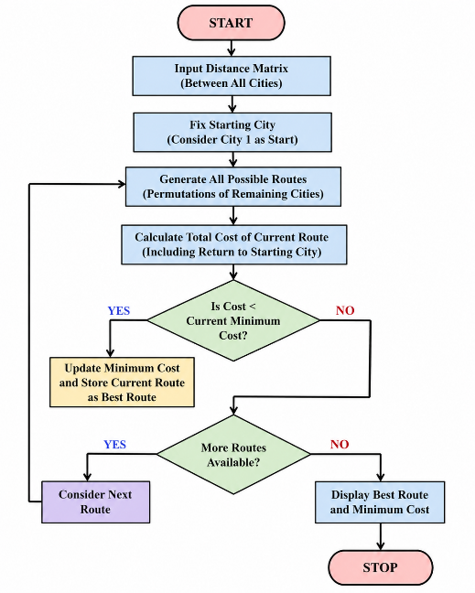
Python Code
from itertools import permutations
graph = [
[0, 10, 15, 20],
[10, 0, 35, 25],
[15, 35, 0, 30],
[20, 25, 30, 0]
]

n = len(graph)
cities = list(range(n))

min_cost = float('inf')
best_path = []

for perm in permutations(cities[1:]):
path = (0,) + perm
cost = 0

for i in range(len(path)-1):
cost += graph[path[i]][path[i+1]]

cost += graph[path[-1]][0]

if cost < min_cost:
min_cost = cost
best_path = path

print("Optimal Path:", best_path + (0,))
print("Minimum Cost:", min_cost)

Output
Optimal Path: (0, 1, 3, 2, 0)
Minimum Cost: 80
Result
The Travelling Salesman Problem was successfully implemented using Python, and the minimum travel cost was obtained.

Conclusion
The program successfully finds the shortest route by checking all possible paths using the brute-force approach. This method gives the optimal solution but is suitable only for a small number of cities because of its high computational complexity.

EXPERIMENT 10
Implementation of A Search Algorithm Using Python*

Aim
To implement the A* Search Algorithm using Python to find the shortest path between two nodes.

Objective
- To understand informed search algorithms.
- To implement the A* algorithm.
- To determine the shortest path using heuristic values.

Algorithm
- Initialize the Open List with the start node.
- Initialize the Closed List as empty.
- Select the node with the lowest f(n)=g(n)+h(n).
- If the selected node is the goal, stop.
- Otherwise:
  - Expand the node.
  - Calculate g, h, and f values for neighbors.
  - Add/update neighbors in the Open List.
- Move the current node to the Closed List.
- Repeat until the goal is found.
- Display the shortest path.

Flowchart
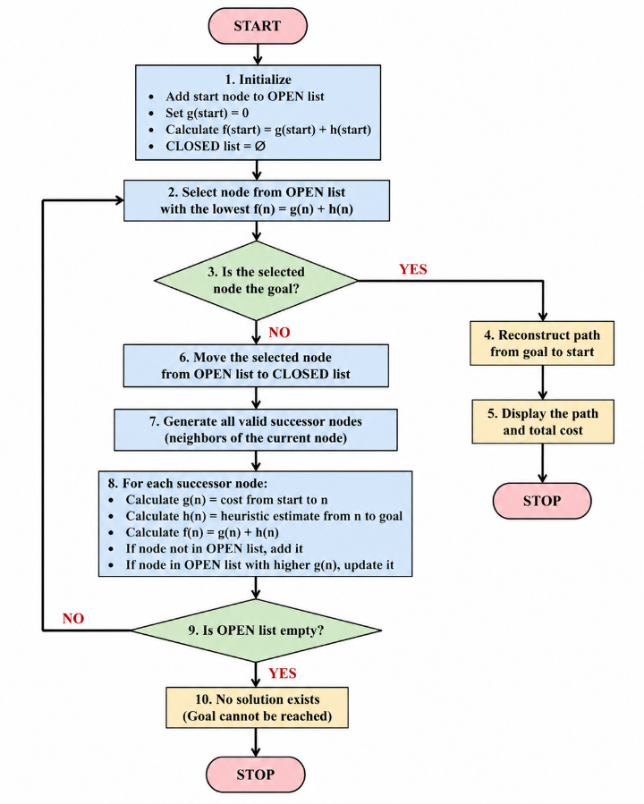
Python Code
graph = {
'A': {'B': 1, 'C': 3},
'B': {'D': 3, 'E': 6},
'C': {'F': 5},
'D': {'G': 4},
'E': {'G': 2},
'F': {'G': 1},
'G': {}
}

heuristic = {
'A': 7,
'B': 6,
'C': 4,
'D': 4,
'E': 2,
'F': 1,
'G': 0
}

def astar(start, goal):
open_list = {start}
closed_list = set()

g = {start: 0}
parent = {start: start}

while open_list:
n = None

for v in open_list:
if n is None or g[v] + heuristic[v] < g[n] + heuristic[n]:
n = v

if n == goal:
path = []

while parent[n] != n:
path.append(n)
n = parent[n]

path.append(start)
path.reverse()

print("Shortest Path:", path)
print("Total Cost:", g[goal])
return

for m, weight in graph[n].items():
if m not in open_list and m not in closed_list:
open_list.add(m)
parent[m] = n
g[m] = g[n] + weight

elif g[m] > g[n] + weight:
g[m] = g[n] + weight
parent[m] = n

if m in closed_list:
closed_list.remove(m)
open_list.add(m)

open_list.remove(n)
closed_list.add(n)

print("Path does not exist!")

astar('A', 'G')

Output
Shortest Path: ['A', 'B', 'D', 'G']
Total Cost: 8

Result
The A* Search Algorithm was successfully implemented using Python, and the shortest path between the start and goal nodes was obtained.

Conclusion
The A* algorithm efficiently finds the optimal path by combining the actual path cost (g(n)) and heuristic estimate (h(n)). Compared with uninformed search algorithms, it significantly reduces the number of explored nodes and is widely used in robotics, GPS navigation, and game AI.

